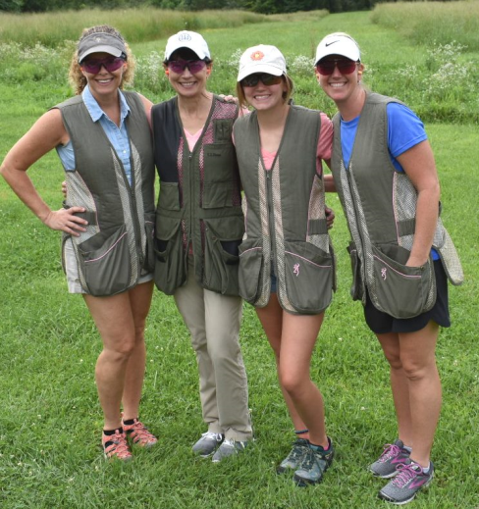

Join us for the 14th annual WHS Sporting Clay Shoot on Friday, August 2, 2019 at Hunting Hills. This will be a 100 target event - 25 stations with four shots each. Shooters of all skill levels are welcome. Prizes are awarded to top teams and top individuals with Junior and Women’s Divisions as well.

Participants must bring their own equipment. Shotguns and shells will not be provided. Shells are available for purchase at Hunting Hills. You are welcome to bring your own cart or ATV vehicle. Teams of four will receive use of a cart. Individuals will be grouped into teams of four.

In addition to the shoot, we’ll have multiple gun raffles, Silent and Chinese auctions and a 50/50 raffle. Gun raffle winners must pass state background check. Proceeds of the shoot benefit programs and projects of Washington Health System. Last year’s event raised $60,000. Help make this year even more successful! For more information, contact Natalie Chaido at (724) 229-2102 or nchaido@whs.org. Visit huntinghills.biz for directions or call (724) 324-2738. Hunting Hills, 181 Hunting Hill Rd, Dilliner, PA 15327

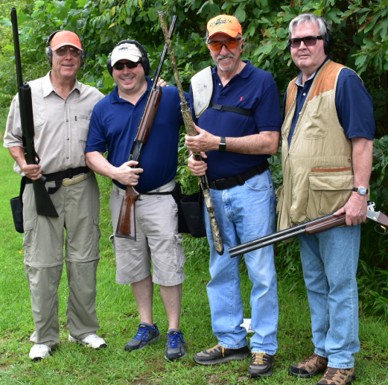

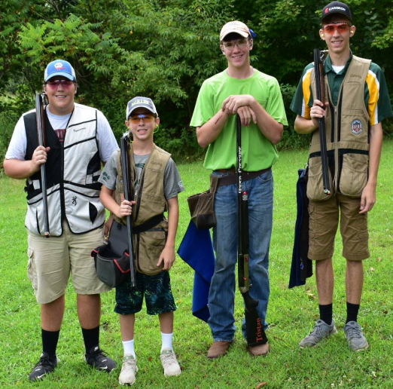

Schedule of Events *

9:00 a.m. to 10:00 a.m.
Registration and Warm Up at Fun Stations

10:00 a.m.
Shotgun Start

12:30 p.m.
Fun Stations Re-Open

12:30 p.m.
Buffet Lunch & Awards Presentation

*Times may vary depending upon speed of play.
2019 Clay Shoot Registration Form

Name:
__________________________________________

Company:
__________________________________________

Team Members Names

_____________________________________________

_____________________________________________

_____________________________________________

_____________________________________________

Address:
__________________________________________

___________________________________________

Telephone: ___________________________________________

Email:
__________________________________________

Register Online:
https://3207.thankyou4caring.org/GiveNow

Enclosed is a check in the amount of:
$_______________

Deadline for registration: July 22, 2019

If sponsoring a level with signage, please email a corporate logo to nchaido@whs.org

Please make check payable to:
Washington Health System Foundation
155 Wilson Avenue
Washington, PA 15301
Sponsorship & Registration Information

_____ $5,000 - Event Sponsor
2 Team Entries (Eight Shooters)
Recognition signage on score board, on course, in printed materials and social media

_____ $3,500 – Shooters’ Gifts Sponsor
Recognition with Shooter’s Gift (as appropriate) and on-course

_____ $2,500 – Score Board Sponsor
Recognition on Event Score Board, in printed materials, on social media & website

_____ $2,000 – Over/Under Sponsor
2 Team Entries (Eight Shooters)
Fun Station Tickets (8), Recognition signage at Score Board, on course, in printed materials and on social media

_____ $1,500 – Five-Stand Sponsor
Recognition signage at Five-Stand

_____ $1,000 – Warm Up Sponsor
Recognition signage at Station

_____ $750 – Lunch Sponsor

_____ $500 – Coffee Break Sponsor

_____ $250 – Station Sponsor

_____ $150 – Cart Sponsor

_____ $125 – Trapper (Event Patron)

_____ $800 Team Registration
1 Team Entry & use of cart

_____ $600 Junior Team Registration
1 Junior Team Entry (16 and Under)

_____ $175 Individual Shooter Registration

_____ $20 Join us for lunch only

2019 Sporting Clay Shoot
Committee

Brian Smith
Washington Financial
Chairman

Pete Campsey

Mike Chaido
Washington Financial

Dave Clapp

Randy Durr
First Energy Corporation

Michael Faust, MD
WHS Washington Pediatrics

Stephanie Faust

Randy Guthrie
Guthrie, Belczyk & Associates

Roy Sisler
Hunting Hills

Ben Romanoff
Ace Sporting Goods

Terry Wiltrout
WHS Greene

155 Wilson Avenue
Washington, PA 15301
(724) 223-3875
www.whs.org
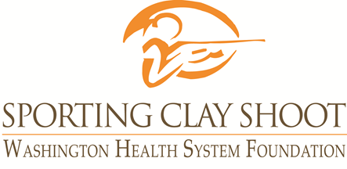
Friday, August 2
Hunting Hills
Dilliner, PA
Presented by

